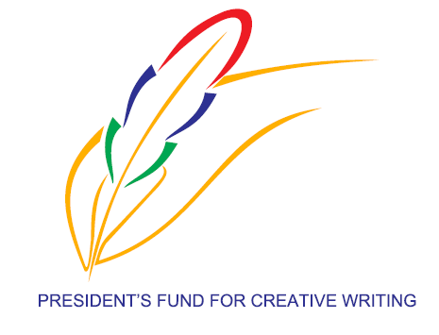
PRESIDENT’S FUND FOR CREATIVE WRITING, under the aegis of the MINISTRY OF ARTS AND CULTURAL HERITAGE
PORT LOUIS
Literary Activity
Theme: “UN POETE NE MEURT JAMAIS”………………..EDOUARD MAUNICK
To pay HOMAGE TO LATE EDOUARD MAUNICK, FAMOUS MAURITIAN POET WHO RECENTLY PASSED AWAY IN FRANCE.
CONDITIONS: Mode: ONLINE
Activity: Write a poem around the above theme.
Length: Minimum 20 lines [around 10 words per line] Maximum: 50 lines
Language: All languages written and spoken in Mauritius [ French, English, Hindi, Urdu, Tamil, Telugu, Marathi, Creole, Bhojpuri, Mandarin, Sanskrit and Arabic]
Deadline for submission of entries: 25 June 2021 at 3 pm
Submit entries clearly marked POETRY COMPETITION to presidentfundcw@gmail.com
A jury panel will select the best entries, whose decision will be final and unchallengeable.
Prizes will be awarded to the 3 best entries in each language used.
The PFCW has the right not to award prizes in case the poems are not relevant and to the required standard or if there are very few submissions in a particular language.
The poems will be deemed to be the property of the PFCW, which can be published or uploaded on the website of the PFCW.
Target group: Any Mauritian national above 18 years.
The participant’s name, age, address and contact details [mobile and landline] should appear at the end of the poem.
Poems must be typed in A4 format using Times New Roman size 12 font, double line spacing and must be well presented.
Scanned copies of well presented handwritten scripts in Asian languages will be considered in case typewriting is not possible.
A participant can send only ONE entry per language.

