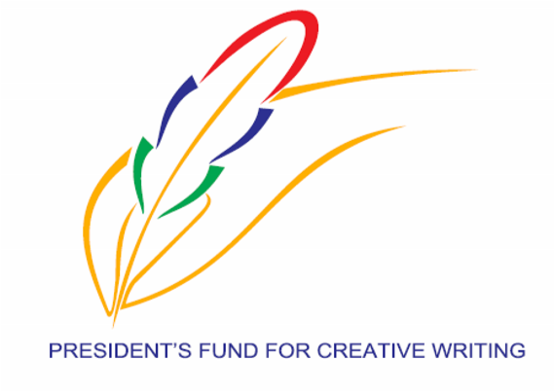
PRESIDENT’S FUND FOR CREATIVE WRITING
C/o MINISTRY OF ARTS AND CULTURAL HERITAGE
7th Floor, Renganaden Seeneevassen Building
Cnr Maillard & Pope Hennessy Streets, Port Louis
Tel: 212 2112; 212 5825

SCHEMES TO ASSIST DESERVING MAURITIAN WRITERS WISHING TO HAVE
THEIR CREATIVE WRITINGS PUBLISHED
APPLICATION FORM

1. General Information
Title (Mr/Mrs/Miss): ………………………………………………………
Surname (Block letters): ………………………………………………….
Other Names: ……………………………………………………………..
National Identity Card No.: ……………………………………………... Residential Address: ………………………………………………………
……………………………………………………….

Tel: .................................Mobile:…………………..Fax : ..............................
E-mail : …………………………………………………………………….
Occupation: ……………………………………………………………….
Employer: ………………………………………………………………….
Office Address: ……………………………………………………………
2. Is this your first application? (Please tick as appropriate)
Yes No

3. Previous Assistance(s) Received
- Previous grant (s) received from the Ministry of Arts and Cultural Heritage:
……………………………………………………………………………….
Title/s of Publication: …………………………………………………………….
- Has any of your written work been published by the PFCW so far?

Yes No
If yes, when and how many?
4. Title of Project: ……………………………………………………………………….
Synopsis of Manuscript (to be enclosed)
State Language: …………………………………………………………………….

5. Option
Two options are offered in terms of assistance for publication of books as follows:
Either
- A financial assistance of Rs 30,000 provided all conditions listed in Annex are fulfilled to the satisfaction of the Fund.
Or
- The PFCW takes charge of the publication subject to all conditions being fulfilled to the satisfaction of the Fund.
Please tick your preference below:
Option (i) Option (ii)
6. I hereby certify that all the information submitted above is true. I understand that application not made on the prescribed form or incomplete application or failure to submit relevant details and annexes (if any), may lead to non-consideration or disqualification of the application.
Date: …………………………… Signature: ………………………………………….…..

Name (In Block Letters): ……………………………….
For Official Use
Complete
Incomplete
Copy of NID
Submitted
Application Form

A Synopsis of the
Publication
Complete
Incomplete
Remarks (If any):
Signature of Officer: ………………………………………………..
Name: ………………………………………………………………..
Date: ……………………………………………………………...….

Signature of Author: ………………………………………………
Name: ……………………………………………………………….

Date: ……………………………………………………………..…
INFORMATION TO APPLICANTS
SUBMISSION OF APPLICATION

A. Application Form together with a synopsis, shall be submitted to:
The Secretary
President’s Fund for Creative Writing
C/o Ministry of Arts and Cultural Heritage
7th floor, Renganaden Seeneevassen Building
Cnr Maillard & Pope Hennessy Streets
Port Louis.

B. ELIGIBILITY

- Mauritian Nationals;
- Mauritians residing abroad;
- Could be one author or collection of works of different authors;
- Could be individual and / or Organisation.

C. CATEGORIES
The work to be published should fall under any one of the following categories:
- Poem
- Short Story
- Novel
- Play
- Fiction

D. CRITERIA FOR ELIGIBILITY
- Authors should register with the Mauritius Society of Authors once their book is published.
- Originality/Creativity of the project; and
- Relevance to local context and themes;

Note:
Application for assistance under this scheme should be in respect of proposed project, otherwise, the request will not be considered.
E. Conditions
- The Guidelines for applicants and application forms will have to be made available by PFCW Secretariat.
- Application should mention the Title of the work and language.
- Applicants should submit a hard copy of the synopsis of the work proposed on one A4 Paper.
- Upon approval of the synopsis, Applicants should submit :
-Financial Assistance:
One hard copy of the manuscript to the PFCW for assessment purposes.
-Publication:
One hard and one soft copies of the manuscript to the PFCW for assessment purposes.
- Upon receipt of the Assessment Report, the successful authors will be informed about the outcome of their request. Authors bear the full responsibility to make all necessary amendments to their texts if required, and to produce their final manuscripts (one hard and one soft copy) to the Fund. The author should adhere to all conditions of the President’s Fund for Creative Writing.
- The Fund will arrange for those manuscripts which are retained to be read and edited by a pool of Readers /Editors, followed by a final assessment by the Quality Control Unit of the PFCW.
- Depending on the option preferred by the Applicant, the Fund will then proceed with the publication of these works, after adhering to all procurement procedures. The works will bear the PFCW logo and the phrase ‘Under the aegis of the Ministry of Arts and Culture’.

(vii) Your attention is drawn to the following responsibilities:
As an author, you shall be responsible for the following:
- Purchase of ISBN number from Edition de L’ Ocean Indien for your particular work;
- Ensuring that the Logo of the PFCW is inserted in the work;
- Ensuring “Under the aegis of Ministry of Arts and Cultural Heritage” clearly features on the work;
- Ensure that the name of the Printer/Publisher appears on the work.

- According to established rule, the PFCW will keep 50 copies and the remaining 450 copies are handed to the author.
- The author shall be the copyright holder of his work.
- An author shall be eligible for financial assistance once every three years.
- All publications by the PFCW shall be launched by the PFCW.

- The PFCW does not extend assistance for works that have already been published before.

